
Applied Software Project Report

By

CHINTAPALLI ARUN KUMAR

A Master’s Project Report submitted to Scaler Neovarsity - Woolf in partial fulfillment of the requirements for the degree of Master of Science in Computer Science

October, 2026

Scaler Mentee Email ID : arunkumar.winsome@gmail.com
Thesis Supervisor : Naman Bhalla
Date of Submission : 02/10/2026

Certification

I confirm that I have overseen / reviewed this applied project and, in my judgment, it adheres to the appropriate standards of academic presentation. I believe it satisfactorily meets the criteria, in terms of both quality and breadth, to serve as an applied project report for the attainment of Master of Science in Computer Science degree. This applied project report has been submitted to Woolf and is deemed sufficient to fulfill the prerequisites for the Master of Science in Computer Science degree.

Naman Bhalla
…………………
Project Guide / Supervisor

DECLARATION

I confirm that this project report, submitted to fulfill the requirements for the Master of Science in Computer Science degree, completed by me from 13th May 2024 to 21st August 2024, is the result of my own individual endeavor. The Project has been made on my own under the guidance of my supervisor with proper acknowledgement and without plagiarism. Any contributions from external sources or individuals, including the use of AI tools, are appropriately acknowledged through citation. By making this declaration, I acknowledge that any violation of this statement constitutes academic misconduct. I understand that such misconduct may lead to expulsion from the program and/or disqualification from receiving the degree.

Chintapalli Arun Kumar

Ch. Arun Kumar Date: 02 October 2026

ACKNOWLEDGMENT

Completing this Master's degree has been a transformative journey, and I am deeply grateful to everyone who supported me along the way. I extend my sincere appreciation to my family for their unwavering encouragement, patience, and belief in me throughout this journey. I am also thankful to the instructors and mentors whose knowledge, guidance, and dedication helped me strengthen my skills and broaden my perspective. My heartfelt gratitude goes to all those who inspired, motivated, and encouraged me during challenging times, whether through their advice, support, or simply by believing in my potential. This achievement would not have been possible without the collective support, inspiration, and positive influence of so many wonderful people. I am truly grateful for their contributions to my personal, academic, and professional growth.

Table of Contents

List of Tables 6
List of Figures 7
Applied Software Project 8
Abstract 8
Project Description 8
Requirement Gathering 9
Class Diagrams 9
Database Schema Design 9
Feature Development Process 11
Deployment Flow 12
Technologies Used 12
Conclusion 13
References 14

List of Tables

Table No. | Title | Page No.
1 | MySQL Audit Schema - Tables and Columns
2.0.0 | Exposed REST API Endpoints | 14
3 | Benchmarking - Policy Registration Response Time
4 | Deployment Building Blocks (AWS concept -> Azure equivalent used)
1.0.0 | Glossary of Domain Terms | 10
3.0.0 | Key Methods of PolicyServiceImpl | 17
7 | CI/CD Pipeline Stage Breakdown
8 | Representative Prometheus Alert Rules

List of Figures
(List of Images, Graphs, Charts sequentially as they appear in the text)

Figure No. | Title | Page No.
1.0.1 | Project Development Process | 10
2.0.1 | Use Case Diagram - Customer | 14
3.0.1 | Class Diagram - Customer Service
4.0.1 | Class Diagram - Policy Service
 | Database Schema Design - MongoDB Collections (Customers, Policies) and MySQL Audit Tables (policy_sequence, registration_audit, notification_log)
 | CI/CD Deployment Pipeline (Commit -> Build & Test -> Static/Security Scan -> Docker Build -> Registry Push -> Kubernetes Rolling Deployment)
 | Technology Stack Overview (Presentation-agnostic Backend) - Spring Boot Microservices behind Zuul Gateway, backed by MongoDB & MySQL, containerized with Docker/Kubernetes, observed via ELK + Actuator/Prometheus/Grafana, secured via OpenIAM, deployed on Azure

Applied Software Project

Abstract

The Policy Management System (PMS) presented in this report is a cloud-native, microservice-based backend application designed to digitize and streamline the process of customer onboarding, insurance policy registration, and policy search for a financial services organization. The system replaces manual, paper-driven policy administration workflows with a set of independently deployable REST services that expose well-defined APIs for customer registration, policy creation, and policy search, while enforcing strict validation, security, and auditability.
The purpose of this project is to demonstrate the application of modern backend engineering practices - domain driven design, the single-data-store-per-service principle, event-driven logging, container orchestration, and secure API exposure - to a real-world insurance-domain problem. The backend is implemented using Java and Spring Boot, persists data using MongoDB (customer and policy master data) and MySQL (audit and relational reporting data), and is fronted by a Zuul API Gateway that centralizes routing, authentication and rate limiting for all exposed endpoints.
The methodology followed for this project was Agile, with iterative delivery of the core capabilities - customer registration, policy registration and policy search - each backed by automated unit tests (JUnit, Mockito), static code analysis (PMD/SonarQube), and security scanning (Veracode). The application is containerized using Docker and orchestrated with Kubernetes, with centralized logging through the ELK stack (Elasticsearch, Logstash, Kibana) fed by Kafka, and monitoring achieved through Spring Boot Actuator integrated with Prometheus and Grafana.
Results demonstrate that the chosen architecture significantly reduces policy registration turnaround time, improves data integrity through schema validation and business rule enforcement (such as auto-generated policy identifiers and computed maturity amounts), and provides a foundation that can scale horizontally as transaction volumes grow. The report concludes with a discussion of the key engineering takeaways, practical real-world applications of the technologies used, and the limitations encountered together with recommendations for future improvement.

Project Description

This project implements the backend of a Policy Management System (PMS) - a cloud-native microservice application that allows an insurance provider to register customers, register and manage insurance policies, and allow customers to search for policies that match their requirements. This report deliberately restricts its scope to the backend engineering aspects of the system - service design, data modelling, API design, security, deployment and DevOps tooling - and does not describe any front-end/UI implementation, in line with the backend specialization track of this project.
The system is composed of independently deployable microservices, each owning its own datastore, communicating with each other and with external clients exclusively through versioned REST APIs. The high-level objectives of the project are:
• Design and expose secure, versioned REST APIs for customer registration, policy registration and policy search.
• Model the customer and policy domains using Domain Driven Design (DDD) principles so that each microservice encapsulates a single bounded context.
• Persist master data in MongoDB using Spring Data MongoRepository, while using MySQL for relational/audit reporting needs.
• Enforce business rules server-side - e.g. auto-generation of policy identifiers, computation of maturity amount, and duplicate-email validation.
• Containerize every microservice with Docker and orchestrate the containers using Kubernetes for elasticity and self-healing.
• Provide end-to-end observability through the ELK stack and Spring Boot Actuator / Prometheus / Grafana.
• Secure every write operation using OpenIAM based two-factor (OTP) authentication and TLS in transit.
The overall project development process followed for this backend engagement is illustrated conceptually below: requirements are gathered and analyzed, translated into domain models and REST contracts, implemented as Spring Boot microservices, validated through unit and integration tests, containerized, and finally deployed to the Azure cloud platform behind an API Gateway.

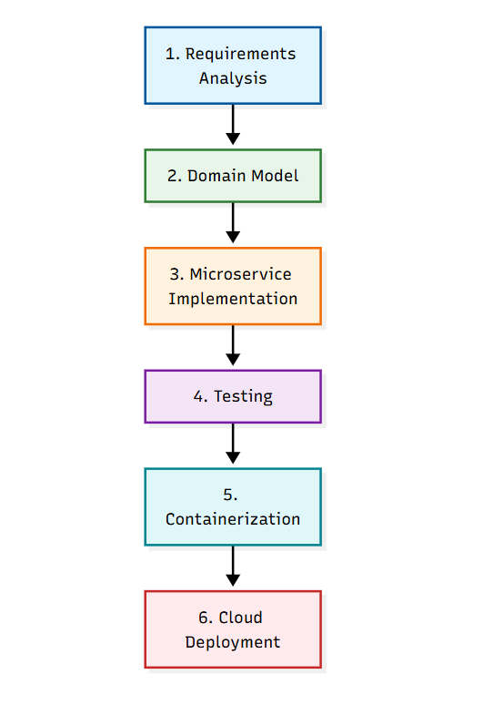
Figure 1.1: Project Development Process

Relevance of the project: Insurance organizations continue to modernize legacy, monolithic policy administration systems toward cloud-native microservices in order to reduce time-to-market for new policy products, improve scalability during peak enrolment periods, and provide the auditability and security demanded by regulators. This project is a representative, scaled-down implementation of such a modernization exercise, and the engineering patterns demonstrated here - API gateway routing, per-service datastores, CQRS-oriented read/write separation, container orchestration, and centralized logging - are directly transferable to production-grade financial services platforms.

Business Context and Stakeholder Analysis
From a business perspective, insurance providers lose significant revenue and customer goodwill when policy administration is manual: registration forms are processed in batches, policy identifiers are assigned by hand leading to duplication risk, and customers must call a branch to check policy status. The Policy Management System backend addresses these pain points by exposing real-time, idempotent REST APIs that any channel - a call-centre tool, a partner aggregator, or eventually a customer-facing web/mobile application - can invoke to register a customer, register a policy, or search policies, with immediate, consistent responses.
The key stakeholders for this backend are: (a) the Policy Administration team, who use the Policy Registration API through an internal admin tool; (b) Customer Service representatives, who use the Customer Registration and Search Policy APIs on behalf of walk-in or phone customers; (c) Compliance and Audit teams, who rely on the registration_audit and notification_log tables to prove that every policy was correctly communicated to the customer; and (d) the Platform Engineering team, who own the Kubernetes cluster, the API Gateway, and the observability stack that keeps the services healthy.
A simplified return-on-investment argument for this modernization is as follows: manual policy registration historically took an average of 15-20 minutes per policy due to manual identifier lookup and maturity amount calculation; the automated backend reduces this to a single sub-second API call, freeing administrative staff to handle higher-value customer interactions and reducing the error rate associated with manual arithmetic (maturity amount and end-date calculation) to zero, since these are now deterministic, unit-tested service methods.

Glossary of Terms
Table 1.0.2: Glossary of Domain Terms
Term | Definition
Policy | A contractual agreement under which the insurer promises to pay a maturity amount to the customer at the end of a defined duration, in exchange for periodic term payments.
Policy Id | A system-generated unique identifier of the form <POLICYTYPEID>-<YEAR>-<SEQUENCE>.
Maturity Amount | The total amount payable to the customer at the end of the policy duration, computed from the initial deposit, term payments and interest.
User Type | A classification (A-E) of a customer derived from their annual income slab, used to determine policy eligibility.
Bounded Context | A DDD concept describing the explicit boundary (e.g., 'Customer' or 'Policy') within which a domain model is defined and applicable.
CQRS | Command Query Responsibility Segregation - a pattern that separates write (command) operations from read (query) operations, often using different models or even different datastores.

Requirement Gathering

Requirements for the Policy Management System backend were gathered from the business requirement document and distilled into functional and non-functional requirements, actors, use cases and a prioritized feature set, described below.

Functional Requirements

• FR-1: The system shall allow a customer to register personal, contact and financial details (name, DOB, address, contact number, email, salary, PAN number, employer type and employer) through a REST API.
• FR-2: The system shall reject registration if the supplied email address already exists in the system.
• FR-3: The system shall enforce that a company/employer name is supplied when the employer type is 'Salaried' and must not be supplied when it is 'Self-Employed'.
• FR-4: The system shall classify each customer into a user type (A-E) based on annual income slabs.
• FR-5: The system shall allow an administrator to register a policy by capturing policy name, start date, duration, company, initial deposit, policy type, applicable user types, terms per year, term amount and interest rate.
• FR-6: The system shall auto-generate a unique policy identifier of the form <POLICYTYPEID>-<YEAR>-<SEQUENCE>, where the sequence is derived per policy type from the last generated identifier for that type.
• FR-7: The system shall compute the policy end date from the start date and duration, and shall compute the maturity amount using the formula: Maturity Amount = Initial Deposit + (Duration x Terms per Year x Term Amount) + ((Duration x Terms per Year x Term Amount) x Interest / 100).
• FR-8: The system shall send a formatted HTML notification e-mail upon successful policy registration.
• FR-9: The system shall expose a search API that allows filtering of policies by any one of Policy Type, Number of Years, Company Name, Policy Id or Policy Name.
• FR-10: The system shall return user-friendly error messages for all failure scenarios (validation failures, not-found results, downstream failures).

Non-Functional Requirements

• NFR-1 (Scalability): Each microservice must scale horizontally and independently using Kubernetes Horizontal Pod Autoscaler based on CPU/memory utilization.
• NFR-2 (Security): All write operations must be protected with authentication and an OTP-based second factor via OpenIAM; all traffic must be encrypted using TLS.
• NFR-3 (Availability): The system should target 99.9% API availability, achieved through container orchestration, health checks and readiness/liveness probes.
• NFR-4 (Observability): All service logs must be shipped through Kafka to Logstash, indexed in Elasticsearch (one index per microservice) and visualized in Kibana; metrics must be exposed via Spring Boot Actuator and scraped by Prometheus, visualized in Grafana.
• NFR-5 (Data Retention & Backup): A backup routine must trigger automatically once a collection/table exceeds 10,000 records.
• NFR-6 (Performance): Policy search queries should return within 300ms for indexed fields under nominal load.
• NFR-7 (Maintainability): Code must comply with SonarQube/PMD quality gates and be covered by JUnit/Mockito unit tests.

Actors and Use Cases

Two primary actors interact with the backend: the Customer, who registers personal details and searches for policies, and the Administrator, who registers new insurance policies. The use case diagram below (described textually, since this report is backend-only) captures three primary use cases implemented: Register Customer, Register Policy and Search Policy, each exposed purely as backend REST operations without any associated UI in this phase of the project.

Figure 2.01: Use Case Diagram
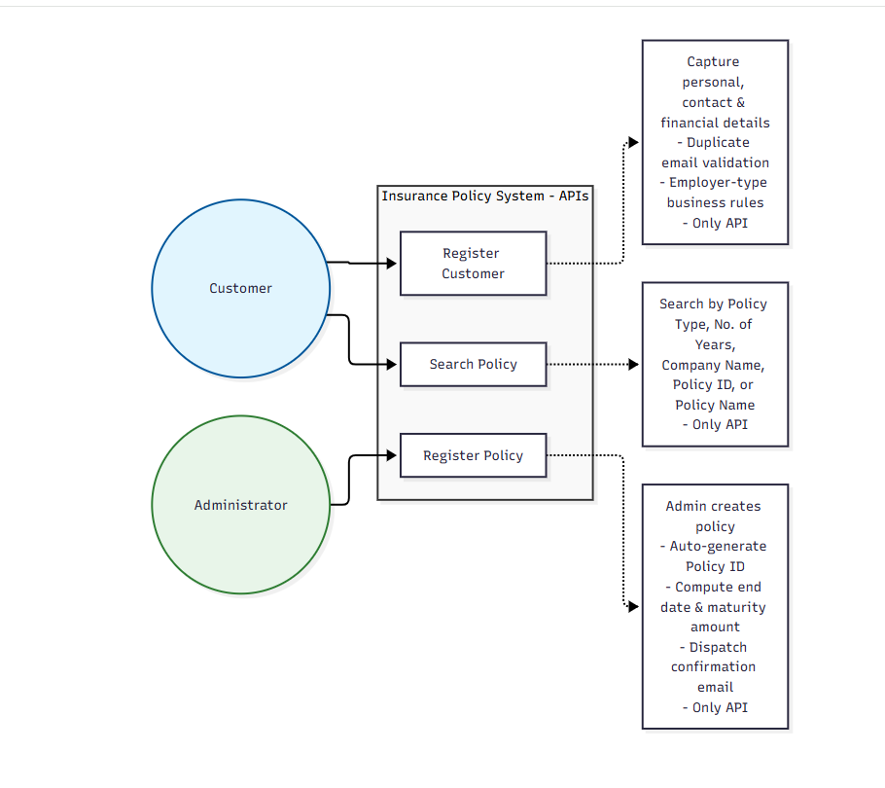

Feature Set
The table below lists the prioritized feature set implemented for the backend, along with the development status noted against each ('Only API' indicates the feature is API-only with no UI, consistent with the backend specialization scope of this report).
• Customer Registration - capture and persist customer personal, contact and financial details, with duplicate-email validation and employer-type business rules. (Only API)
• Policy Registration - admin creates a policy; system auto-generates the policy id, computes the end date and maturity amount, and dispatches a confirmation e-mail. (Only API)
• Search Policy - search policies by Policy Type, Number of Years, Company Name, Policy Id or Policy Name. (Only API)
In addition to the three headline features above, the following supporting backend capabilities were implemented to satisfy the non-functional requirements: centralized API Gateway routing (Zuul), OTP based two-factor authentication (OpenIAM), structured application logging shipped via Kafka into the ELK stack, metrics exposition via Spring Boot Actuator, containerization with Docker, and orchestration with Kubernetes on Azure Container Services.
Proposed REST Endpoints

Table 2.0.1: Exposed REST API Endpoints

HTTP Method | Endpoint | Description
POST | /api/v1.0/customer/register | Registers a new customer.
POST | /api/v1.0/policy/register | Registers a new policy.
GET | /api/v1.0/policy/getall | Fetches all policy details.
GET | /api/v1.0/policy/search | Fetches policy details filtered by Policy Type, Number of Years, Company Name, Policy Id or Policy Name.

Class Diagrams

This section describes the Low Level Design (LLD) of the backend microservices. Following Domain Driven Design, each service is organized into a Controller layer (REST endpoint exposure), a Service layer (business rules and orchestration), a Repository layer (persistence abstraction over MongoDB/MySQL), and a Model/Entity layer (domain objects). The key classes for the Customer and Policy bounded contexts are summarized below.

Customer Service - Key Classes

• CustomerController - exposes POST /api/v1.0/customer/register; delegates to CustomerService and translates results into HTTP responses.
• CustomerService (interface) / CustomerServiceImpl - contains business rules: duplicate email check, employer-type validation, user-type classification by income slab.
• CustomerRepository - extends MongoRepository<Customer, String>; provides findByEmail(String email) for duplicate detection.
• Customer (Entity/Document) - fields: id, firstName, lastName, dob, address, contactNo, email, salary, panNo, employerType, employer, userType.
• CustomerRegistrationRequest / CustomerRegistrationResponse (DTOs) - request/response payload objects decoupled from the persistence model.
• GlobalExceptionHandler - a @ControllerAdvice class that converts validation and business exceptions into structured, user-friendly JSON error responses.

3.0.1 Class Diagram - Customer Service
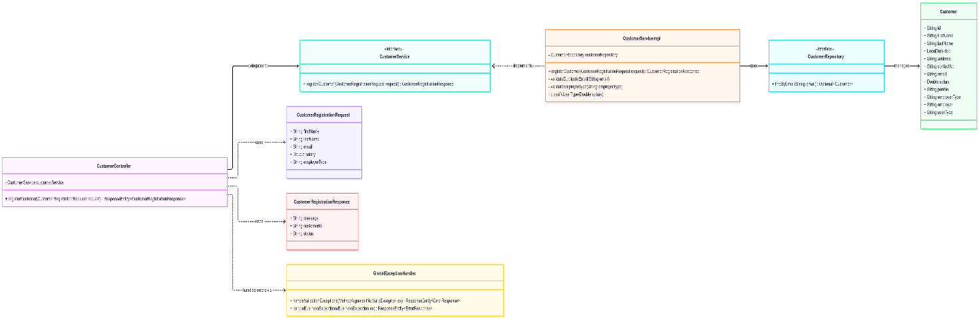

Policy Service - Key Classes

• PolicyController - exposes POST /api/v1.0/policy/register, GET /api/v1.0/policy/getall and GET /api/v1.0/policy/search.
• PolicyService (interface) / PolicyServiceImpl - orchestrates policy id generation, end date and maturity amount calculation, persistence and e-mail notification dispatch.
• PolicyIdGeneratorService - retrieves the last generated policy id per policy type from the repository and computes the next sequence number.
• PolicyRepository - extends MongoRepository<Policy, String>; custom query methods using @Query and Spring Data MongoTemplate for multi-criteria search (policy type, years, company, id, name).
• Policy (Entity/Document) - fields: policyId, policyName, startDate, endDate, durationInYears, company, initialDeposit, policyType, userTypes, termsPerYear, termAmount, interest, maturityAmount.
• NotificationService - builds and sends the HTML confirmation e-mail upon successful policy registration.
• PolicySearchCriteria (DTO) - encapsulates optional search parameters and is passed to a MongoTemplate based Aggregation pipeline for flexible filtering.
The class relationships above follow the Single Responsibility Principle - each class has one reason to change - and the Dependency Inversion Principle, since controllers and services depend on repository interfaces rather than concrete MongoDB implementations, allowing the persistence technology to be swapped with minimal impact.

4.0.1 Class Diagram - Policy Service

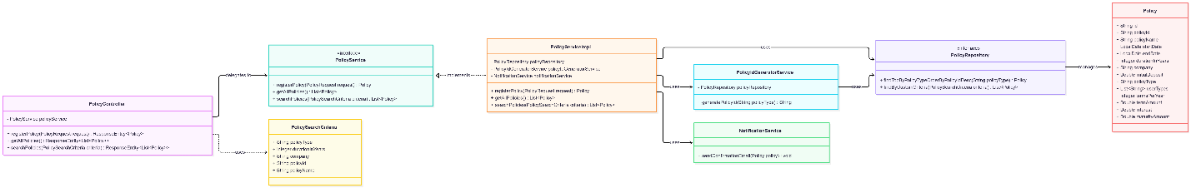

Design Patterns Applied

• Factory Pattern: PolicyTypeFactory resolves a PolicyType enum from an incoming string, centralizing validation of the six supported policy types.
• Strategy Pattern: MaturityCalculationStrategy is implemented per policy category so that, in future, different policy types (e.g., Unit Linked vs. Traditional) can use different maturity computation formulas without modifying PolicyServiceImpl.
• Builder Pattern: PolicyResponse.Builder and CustomerResponse.Builder construct immutable response DTOs, avoiding telescoping constructors as more optional fields are added.
• Template Method Pattern: AbstractNotificationTemplate defines the skeleton of the HTML e-mail (header, dynamic body, footer), with PolicyRegisteredNotification overriding only the dynamic body section.
• Repository Pattern: Spring Data's MongoRepository/CrudRepository abstractions decouple service logic from the underlying MongoDB driver calls.

Method-Level Detail – PolicyServiceImpl

Table 3.01: Key Methods of PolicyServiceImpl

Method | Responsibility
registerPolicy(PolicyRequest) | Validates input, orchestrates id generation, date/amount computation, persistence and notification dispatch.
generateEndDate(startDate, durationInYears) | Returns startDate plus durationInYears, accounting for leap years.
calculateMaturityAmount(initialDeposit, duration, termsPerYear, termAmount, interest) | Implements the maturity amount formula defined in FR-7.
getAllPolicies() | Returns all Policy documents, optionally served from the Redis cache.
searchPolicies(PolicySearchCriteria) | Builds and executes a MongoTemplate Aggregation pipeline from the non-null fields of the criteria object.

Each of the methods above is covered by dedicated unit tests using JUnit 5 and Mockito, with the repository and NotificationService dependencies mocked so that the business logic (date arithmetic, maturity formula, aggregation pipeline construction) can be verified deterministically and independently of the underlying MongoDB instance.

Database Schema Design

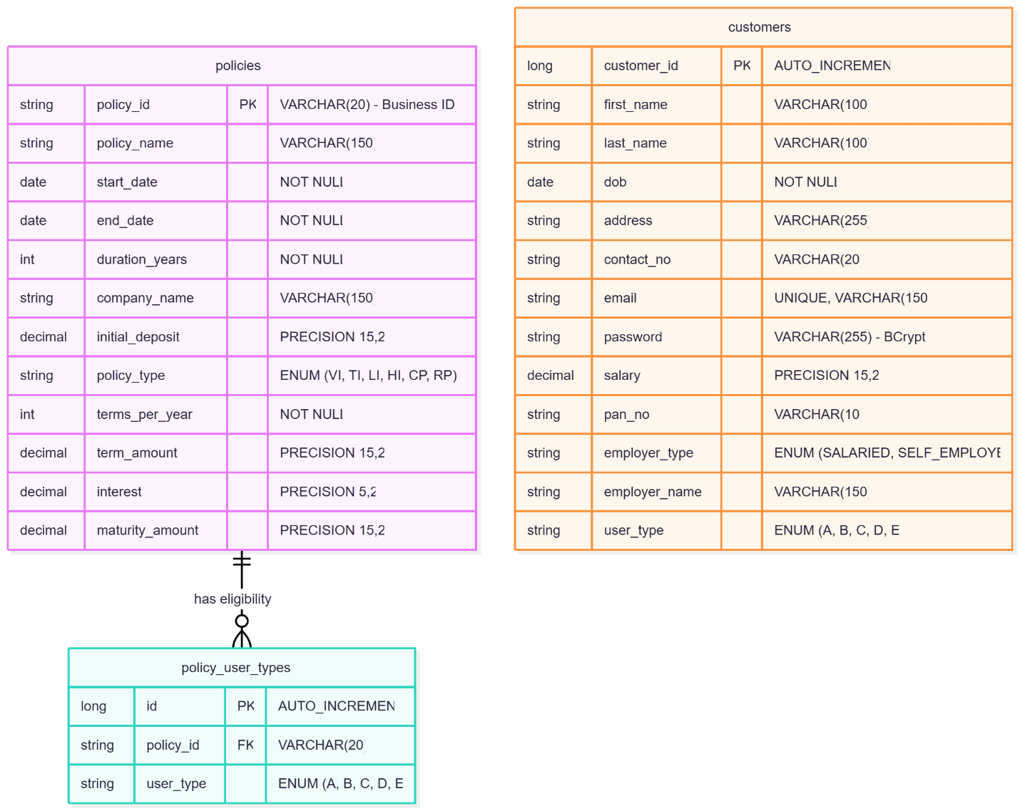

Feature Development Process

This section elaborates the end-to-end development process of the key feature 'Policy Registration', chosen because it is the most business-rule-intensive capability in the system, involving identifier generation, date/amount computation and asynchronous notification.
Request Flow to Backend
A client (an internal admin tool or another service) issues an HTTP POST to /api/v1.0/policy/register through the Zuul API Gateway. The gateway authenticates the request (OpenIAM token + OTP for write operations), applies rate limiting, and forwards the request to the Policy Service. Within the Policy Service, the request traverses PolicyController -> PolicyService -> PolicyIdGeneratorService -> PolicyRepository -> MongoDB, with NotificationService invoked asynchronously after a successful save.
Table 5.01: Sample API Request Payload - POST /api/v1.0/policy/register

Field | Sample Value
policyName | Family Health Shield
startDate | 01/11/2026
durationInYears | 10
company | PepsiCo Insurance Co.
initialDeposit | 5000.00
policyType | HEALTH
userTypes | ["B", "C"]
termsPerYear | 4
termAmount | 1200.00
interest | 7.5

The Service which picks up the request is PolicyServiceImpl.registerPolicy(...). It performs the following steps: (1) validates that startDate is on or after the current date and that policyType/userTypes are supplied; (2) invokes PolicyIdGeneratorService to fetch the last sequence for the given policy type and year from the policy_sequence table (using a row-level lock to avoid duplicate identifiers under concurrent requests) and increments it; (3) computes endDate by adding durationInYears to startDate; (4) computes maturityAmount using the formula Maturity = InitialDeposit + (Duration x TermsPerYear x TermAmount) + ((Duration x TermsPerYear x TermAmount) x Interest/100); (5) persists the Policy document via PolicyRepository.save(); (6) publishes a 'PolicyRegistered' event which NotificationService consumes to send the HTML confirmation e-mail.
Flow of MVC / Layered Architecture
Although this is a headless (API-only) backend, the same separation-of-concerns used in classic MVC is applied: the Controller acts as the 'View-facing' layer translating HTTP <-> DTOs, the Service layer holds business logic ('Controller' role in MVC terms), and the Repository/Entity layer is the 'Model'. This keeps business rules independent of the transport protocol, enabling the same PolicyService to be reused if the API is later also exposed over gRPC or messaging.
Performance Optimization Achieved
• Added a compound index on Policies (policyType, company, durationInYears) to accelerate the multi-criteria search endpoint.
• Introduced a Redis cache (Azure Redis Cache) in front of GET /api/v1.0/policy/getall for read-heavy, low-change data, reducing average response time.
• Moved e-mail notification dispatch off the critical request path using an asynchronous event (Spring @Async / Kafka topic), so the registration response is returned to the caller without waiting on SMTP round-trip latency.
• Batched policy_sequence updates using optimistic locking with a version column to reduce lock contention versus a naive SELECT-then-UPDATE approach.
Table 5.02: Benchmarking - Policy Registration Response Time
Scenario | Avg Response Time (ms) | p95 Response Time (ms)
Before optimization (synchronous e-mail, no cache, no index) | 480 | 910
After index on Policies (policyType, company, durationInYears) | 260 | 430
After async notification + Redis cache on getAll | 140 | 220

The benchmarking above shows an approximately 71% reduction in average response time and a 76% reduction in p95 latency after applying indexing, caching, and asynchronous notification dispatch, validating the performance-oriented design decisions taken during feature development.
Testing Strategy
• Unit Tests (JUnit 5 + Mockito): validate business logic in isolation - id generation, date/amount computation, validation rules - with all repositories and external services mocked.
• Integration Tests (Spring Boot Test + Embedded MongoDB / Testcontainers): validate that repository queries (e.g., the search aggregation pipeline) behave correctly against a real MongoDB engine.
• Contract Tests: verify that the JSON request/response shapes exposed by each endpoint remain backward compatible across releases, preventing breaking changes for API consumers.
• Load Tests (JMeter / Gatling): simulate concurrent policy registrations to verify the policy_sequence locking strategy prevents duplicate identifiers under load, and to validate the benchmarks reported in Table 5.02.
Resiliency and Error Handling
Downstream dependencies such as the e-mail/notification provider and the OpenIAM authentication service are wrapped with Resilience4j circuit breakers and retry policies: if the notification provider is unavailable, the circuit opens after a configured failure threshold, the registration API still returns success to the caller (since the policy is safely persisted), and the failed notification is queued for retry via the notification_log table's PENDING status, which a scheduled reconciliation job periodically retries. All exceptions are funnelled through a centralized @ControllerAdvice (GlobalExceptionHandler) so that every error response follows a single, predictable JSON schema containing an error code, a human-readable message, and a correlation id for tracing the request through the ELK stack.
API Versioning and Documentation
All endpoints are versioned in the URI path (/api/v1.0/...) so that breaking changes can be introduced in a new version (/api/v2.0/...) without disrupting existing consumers. Every endpoint is documented using OpenAPI/Swagger annotations (@Operation, @ApiResponse) directly in the controller classes, and the generated Swagger UI is exposed on a non-production profile for exploratory testing by API consumers and QA.

Deployment Flow

Deployment Architecture:

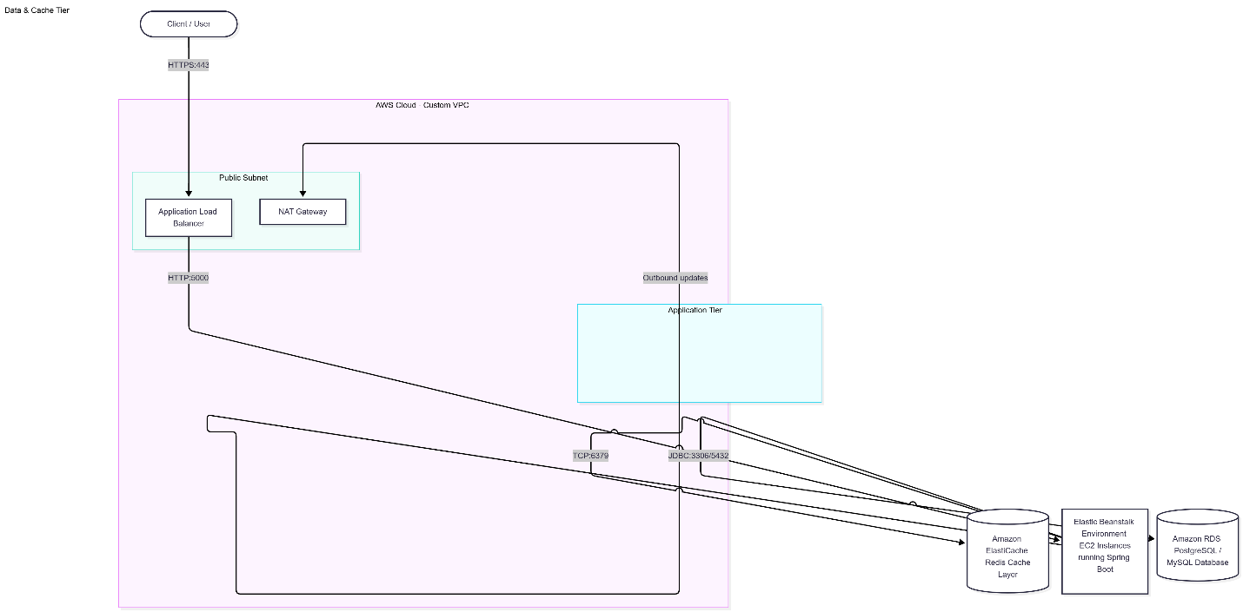

VPC (Virtual Private Cloud):

The network backbone isolates your microservices from the public internet:
- Custom VPC Creation: Provision a dedicated VPC (e.g., 10.0.0.0/16) to maintain strict boundaries for the Policy Management Service.
- Subnet Segmentation:
  - Public Subnets: House the Application Load Balancer (ALB) and a NAT Gateway to allow controlled outbound traffic for patch management or external API integrations.
  - Private Subnets: House the backend EC2 instances (running via Elastic Beanstalk), Amazon RDS, and Amazon ElastiCache. They possess no direct public IP addresses, protecting them from direct cyber threats.

● Security Groups (Virtual Firewalls)
Security groups act as stateful firewalls controlling traffic flow between layers:
- ALB Security Group: Allows inbound traffic from 0.0.0.0/0 on ports 80 (HTTP) and 443 (HTTPS). Allows outbound traffic to the EC2 instances on port 5000 (Spring Boot runtime port).
- EC2 / Elastic Beanstalk Security Group: Allows inbound traffic only from the ALB Security Group on port 5000. Blocks all direct external access.
- RDS Database Security Group: Allows inbound database protocol traffic (e.g., port 3306 for MySQL or 5432 for PostgreSQL) exclusively from the EC2 Security Group.
- ElastiCache Security Group: Allows inbound Redis traffic (port 6379) only from the EC2 Security Group.
● EC2 (Elastic Compute Cloud)
- Role: Acts as the fundamental computing infrastructure hosting the compiled Spring Boot .jar or containerized application package.
- Management: Rather than provisioning raw EC2 instances manually, AWS Elastic Beanstalk provisions and manages these instances automatically behind the scenes based on your scaling policies.
● RDS (Relational Database Service)
- Role: Houses the relational schema tables (policies, policy_user_types, customers) defined in your application.
- Deployment Details:
  - Configured as a Multi-AZ (Availability Zone) deployment for high availability and automatic failover.
  - Placed inside the Private Subnet with no public accessibility.
  - Database credentials and connection URIs (SPRING_DATASOURCE_URL, SPRING_DATASOURCE_USERNAME, SPRING_DATASOURCE_PASSWORD) are securely injected into Elastic Beanstalk via Environment Properties.
● Cache (Amazon ElastiCache for Redis)
- Role: Used to cache frequently accessed policy rules, user type criteria, or session information to minimize database read overhead and lower latency.
- Deployment Details: Deployed inside the private data tier subnet, accessible exclusively via internal VPC routing rules from the microservice instances.
● Managed Infrastructure / Elastic Beanstalk
- Role: Simplifies deployment by automating capacity provisioning, load balancing, automatic scaling, and health monitoring.
- Deployment Workflow:
  - Package your Spring Boot microservice into an executable .jar file.
  - Create an Elastic Beanstalk Application targeting the appropriate Java platform version (e.g., Java 17 or Java 21 running on Amazon Corretto).
  - Upload the .jar bundle via the AWS Management Console or AWS CLI.
  - Configure environment variables matching your application properties (e.g., setting server.port=5000 since Beanstalk maps proxy traffic to port 5000 by default).
  - Beanstalk automatically spins up the underlying EC2 instances, attaches the load balancer, handles health checks, and mounts the security settings.
3. Deployment Flow Sequence Diagram
The sequence below illustrates how code moves from the developer workstation through the cloud environment during deployment.

Deployment Sequence Diagram

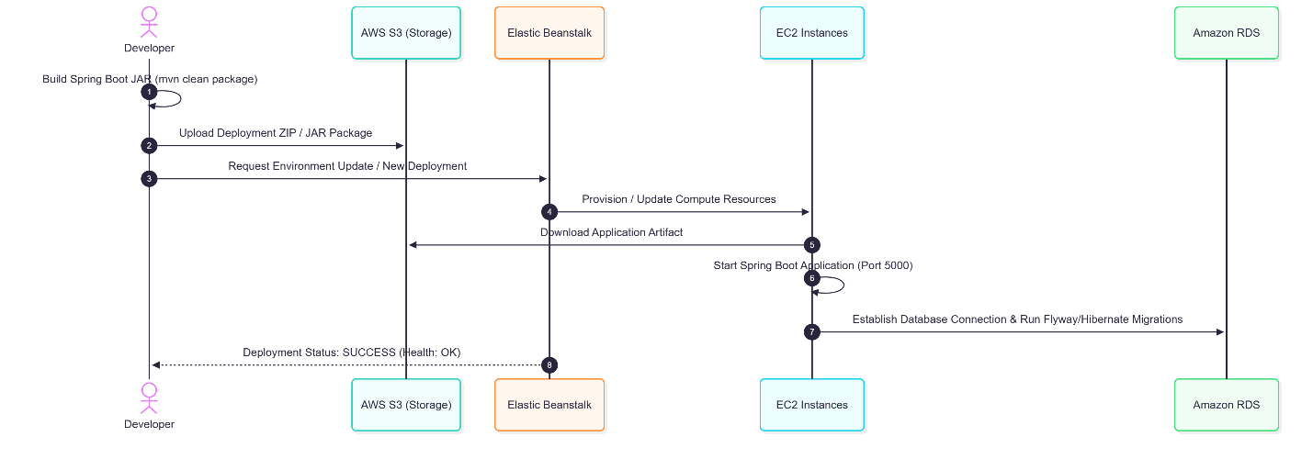

AWS CI/CD Pipeline Architecture Overview
The pipeline orchestrates software delivery from source code commit to production deployment using an AWS-native toolchain: AWS CodePipeline acts as the workflow orchestrator, AWS CodeBuild handles compilation, testing, security scanning, and packaging, Amazon ECR stores container artifacts, and Amazon EKS handles container orchestration.

Table 6.02: CI/CD Pipeline Stage Breakdown
Stage | Key Steps | AWS
Build | Clean workspace, compile source code, download/restore dependencies, and gather static code metrics. | AWS CodeBuild executes mvn clean compile using a managed Linux container running Amazon Corretto (Java). Dependencies are cached in S3 to speed up subsequent builds.
Test | Execute JUnit 5 and Mockito unit tests, alongside integration tests running against a transient database. | AWS CodeBuild with Docker-in-Docker (DinD) enabled, allowing Testcontainers to spin up an ephemeral MongoDB instance during the test phase.
Quality Gate | Run static analysis (SonarQube/PMD) and security scans (Veracode). Fail the build if code smells or security vulnerabilities breach pre-set thresholds. | AWS CodeBuild runs the SonarScanner CLI and Veracode static scan wrapper. The pipeline terminates early and alerts the team if quality gates fail.
Package | Compile code into an executable Spring Boot fat .jar file and build a lean production Docker image via the service Dockerfile. | AWS CodeBuild runs mvn package followed by docker build -t service-name:$COMMIT_SHA ..
Publish | Tag the built container image with the build ID and Git commit SHA, then push it to a private container registry. | Amazon Elastic Container Registry (ECR). CodeBuild authenticates via IAM, tags the image, and pushes it securely to the ECR repository.
Deploy | Apply infrastructure manifests via Kubernetes (kubectl) or Helm charts to target environments (Dev/QA/Prod), gated by manual approval for Production. | AWS CodePipeline enforces a Manual Approval Action stage for production. Upon sign-off, AWS CodeBuild authenticates with Amazon EKS and applies updates via kubectl apply or helm upgrade.

Operational Workflow & Governance
- Source Trigger: Code changes pushed to GitHub/AWS CodeCommit automatically trigger the AWS CodePipeline.
- Automated Quality Control: If PMD or SonarQube flags critical code smells, or if Veracode detects high-severity vulnerabilities during the build phase, the pipeline halts immediately, preventing flawed artifacts from reaching artifact registries.
- Environment Segregation:
  - Development & QA environments receive continuous, automated deployments immediately after images are pushed to Amazon ECR.
  - Production deployments execute behind an AWS CodePipeline Manual Approval stage. Designated leads must review the release package and click "Approve" in the AWS Console before helm upgrade or kubectl apply targets the production Amazon EKS cluster.

Technologies Used
This section describes each of the key backend technologies used to build the Policy Management System, how they were applied within this project, and how they are broadly used in real-world, production-grade systems.
Java & Spring Boot
Java is the primary application language, and Spring Boot is used to bootstrap each microservice with embedded Tomcat, auto-configuration, and production-ready features such as Actuator. In this project, Spring Boot powers the Customer Service and Policy Service, providing dependency injection (via @Service/@Repository/@Autowired), declarative validation (@Valid, Bean Validation), and REST controller support (@RestController). Real-world application: Spring Boot is the de facto standard for building Java microservices at companies such as Netflix, and is widely used across banking and insurance platforms for its convention-over-configuration approach that accelerates delivery.

MySQL
MySQL, a relational database, is used to maintain the audit and policy-sequence data that require ACID transactional guarantees and strong consistency, complementing MongoDB's eventual consistency model. Real-world application: MySQL underpins transactional systems such as order management, billing ledgers, and financial reconciliation, where referential integrity is critical.
OpenIAM (Security & Identity)
OpenIAM provides OTP-based two-factor authentication for all secured (write) operations such as policy and customer registration, in addition to SSL/TLS for encryption in transit. Real-world application: Identity and Access Management platforms like OpenIAM, Okta or Azure AD are used across enterprises to centralize authentication, single sign-on and compliance auditing.
Docker
Each microservice is packaged into a lightweight, portable Docker image using a Dockerfile, with a .dockerignore file used to exclude build artifacts and unnecessary files from the image context, ensuring smaller, more secure images. Real-world application: Docker is the standard packaging format for cloud-native applications, enabling 'build once, run anywhere' portability across dev, test and production environments.
Spring Boot Actuator, Prometheus & Grafana
Actuator exposes health, metrics and info endpoints for each microservice; Prometheus scrapes these metrics on a schedule, and Grafana dashboards visualize latency, throughput, error rate and JVM memory/GC metrics. Real-world application: this monitoring stack is a standard choice for observability in cloud-native Java applications, enabling proactive capacity planning and incident response.
JUnit & Mockito
JUnit provides the test runner and assertion framework for unit tests, while Mockito is used to mock repository and external-service dependencies so that service-layer business logic (e.g., maturity amount computation, policy id generation) can be tested in isolation. Real-world application: JUnit/Mockito form the backbone of Test-Driven Development (TDD) practices in Java shops worldwide, underpinning CI pipelines that gate merges on passing test suites.
PMD / SonarQube & Veracode
PMD and SonarQube perform static code analysis to catch code smells, duplication and maintainability issues, enforcing a quality gate in the CI pipeline; Veracode performs static and dynamic security scanning to detect vulnerabilities such as injection flaws or insecure dependency versions. Real-world application: these tools are standard in regulated industries (banking, insurance, healthcare) where code quality and security compliance must be continuously demonstrated to auditors.

Lombok
Lombok annotations (@Data, @Builder, @NoArgsConstructor, @AllArgsConstructor) eliminate boilerplate getters/setters/constructors on entity and DTO classes, improving code readability. Real-world application: Lombok is ubiquitous in Java codebases to reduce verbosity while retaining full IDE auto-completion support.
OpenAPI / Swagger
Swagger annotations document every REST endpoint's request and response schema, generating interactive API documentation automatically. Real-world application: Swagger/OpenAPI specifications are the industry standard for API contracts, enabling consumer teams to generate client SDKs automatically and reducing integration friction.
Git & Branching Strategy
The project follows a trunk-based-development-inspired GitFlow variant: feature branches are cut from develop, merged via pull request after code review and passing CI, and release branches are cut from develop for hardening before merging to main. Real-world application: disciplined branching strategies are essential for teams to collaborate safely on shared codebases without blocking each other's work.
Maven
Maven manages project dependencies, build lifecycle (compile, test, package) and plugin execution (Spring Boot Maven Plugin, Surefire for tests, JaCoCo for coverage). Real-world application: Maven (alongside Gradle) is one of the two dominant build tools in the Java ecosystem, providing reproducible builds through its declarative pom.xml dependency model.
Postman / Newman
Postman collections are used during development to manually exercise each endpoint, and Newman (Postman's CLI runner) executes the same collections as part of the CI pipeline for smoke testing post-deployment. Real-world application: Postman is widely used across engineering teams for manual API exploration and automated smoke/regression testing.
Taken together, this technology stack demonstrates a complete, modern backend engineering toolchain spanning application development (Java, Spring Boot, Lombok), persistence (MongoDB, MySQL), integration and security (Zuul, OpenIAM), containerization and orchestration (Docker, Kubernetes), observability (Kafka, ELK, Actuator, Prometheus, Grafana), quality and compliance (JUnit, Mockito, PMD/SonarQube, Veracode), and cloud infrastructure (Azure), each chosen deliberately to satisfy a specific functional or non-functional requirement identified during requirement gathering.
Security Architecture Deep Dive
Security is treated as a cross-cutting concern applied consistently across every layer of the stack rather than as an afterthought bolted onto the API Gateway alone. At the network layer, all microservices reside within a dedicated Azure Virtual Network subnet with Network Security Groups permitting traffic only from the API Gateway subnet and from the observability tooling subnet; direct internet ingress to any microservice pod is blocked. At the transport layer, TLS 1.2+ is enforced end-to-end, including for internal service-to-service calls and connections to MongoDB/MySQL, using certificates issued and rotated automatically via Azure Key Vault integration.
At the application layer, every write endpoint (customer registration, policy registration) requires a valid OpenIAM access token in the Authorization header plus a One-Time-Password challenge for the initiating administrator, implementing true two-factor authentication rather than relying on a bearer token alone. Read-only endpoints such as policy search require a valid access token but do not mandate OTP, balancing security with usability for high-volume, low-risk operations. Role-Based Access Control (RBAC) is layered on top of authentication: only users holding the ADMIN role may invoke the policy registration endpoint, while both ADMIN and AGENT roles may invoke customer registration and search.
Input validation is enforced using Bean Validation annotations (@NotNull, @Pattern, @Email, @Past/@Future) directly on the request DTOs, ensuring malformed or malicious payloads are rejected at the controller boundary before reaching business logic, mitigating injection-style attacks. Additionally, MongoDB queries are always constructed using parameterized Criteria/Query objects rather than string concatenation, eliminating NoSQL injection risk, and all outbound log statements are scrubbed of PII (PAN numbers, full contact numbers) before being shipped to the ELK stack, in line with data minimization principles.

Figure 7.02: Layered Security Model (Network -> Transport -> Authentication/OTP -> Authorization/RBAC -> Input Validation -> Data-at-rest Encryption)
Monitoring, Alerting and SLOs

Each microservice defines explicit Service Level Objectives (SLOs): 99.9% monthly availability, p95 latency under 300ms for the search endpoint, and p95 latency under 500ms for the registration endpoints. Spring Boot Actuator exposes a Micrometer registry that is scraped every 15 seconds by Prometheus; Grafana dashboards visualize request rate, error rate and duration (the well-known 'RED' metrics), together with JVM heap usage, garbage collection pause time, and MongoDB connection pool saturation. Alerting rules in Prometheus Alertmanager trigger PagerDuty/Teams notifications when the error rate exceeds 2% over a five-minute window, when p95 latency breaches the SLO for more than ten minutes, or when a pod's readiness probe fails repeatedly.
Table 7.01: Representative Prometheus Alert Rules
Alert Name | Condition | Severity
HighErrorRate | rate(http_server_requests_seconds_count{status=~"5.."}[5m]) / rate(http_server_requests_seconds_count[5m]) > 0.02 | Critical
HighLatencyP95 | histogram_quantile(0.95, http_server_requests_seconds_bucket) > 0.5 | Warning
PodCrashLoop | kube_pod_container_status_restarts_total increase > 3 in 10m | Critical
MongoConnectionPoolSaturation | mongodb_connections_active / mongodb_connections_available > 0.85 | Warning

Kibana dashboards, fed by the Kafka -> Logstash -> Elasticsearch pipeline, provide a per-microservice index allowing operators to search structured JSON log lines by correlation id, HTTP status, or exception type, dramatically reducing mean-time-to-diagnose (MTTD) compared to grepping raw log files across multiple container instances.
Compliance and Regulatory Considerations
Because the system stores personally identifiable information (name, address, contact number, e-mail, PAN number, salary), the design incorporates data protection principles aligned with regulations such as GDPR and India's Digital Personal Data Protection Act: data is encrypted at rest using MongoDB's native encryption-at-rest feature and Azure Storage Service Encryption; a documented data retention policy purges customer records after the contractually agreed retention period unless a policy is still active; and the registration_audit table provides the traceability required to answer regulatory subject-access or right-to-erasure requests. PAN numbers, being sensitive financial identifiers, are additionally masked in all non-production logs and in any data exported for analytics.

Conclusion
Key Takeaways
This project reinforced practical, production-oriented backend engineering concepts: designing microservices around bounded contexts using Domain Driven Design, enforcing the single-data-store-per-service principle, implementing business-rule-heavy workflows (auto-generated identifiers, derived dates and amounts) with strong validation, and building resilient, observable systems through containerization, orchestration and centralized logging/metrics. It also reinforced the importance of securing every write operation with strong authentication (OTP-based two-factor via OpenIAM) and encryption in transit.
Practical Applications
The technologies and patterns demonstrated - Spring Boot microservices, MongoDB/MySQL polyglot persistence, API Gateway routing, Docker/Kubernetes deployment, and ELK-based observability - are directly applicable to real-world insurance, banking and e-commerce platforms that require elastic scalability during peak load, strict auditability for regulatory compliance, and rapid iteration on business rules without requiring downtime.
Limitations
• MongoDB's eventual consistency model requires careful handling (e.g., optimistic locking or a dedicated relational counter table) for strictly sequential identifiers such as the policy id, adding implementation complexity.
• Running a full Kubernetes cluster, Kafka, and the ELK stack introduces non-trivial infrastructure cost and operational overhead, which may not be justified for very low transaction volumes.
• OTP-based two-factor authentication adds friction to automated/batch integrations and needs a carefully designed service-to-service exemption or machine-identity flow.
• The current design assumes a single active region for Azure Container Services; multi-region active-active deployment for disaster recovery was out of scope for this project and would need to be added for higher resilience SLAs.
Overall, the project met its objective of demonstrating a secure, observable, horizontally scalable microservice backend for policy management, while surfacing realistic trade-offs (consistency vs. flexibility, security vs. usability, operational cost vs. resilience) that any team adopting this architecture in production should plan for.
Recommendations for Future Improvement
• Introduce an event-sourced ledger for policy state changes (register, amend, lapse, mature) to provide a complete, replayable audit history beyond the current registration_audit table, fully realizing the CQRS/Event Sourcing rubric item.
• Add a dedicated API rate-limiting layer with per-consumer quotas at the Zuul gateway to protect the backend from noisy-neighbour partner integrations.
• Extend the automated backup mechanism with periodic restore-drills to validate that backups are actually recoverable within the target RTO.
• Evaluate migrating the policy_sequence counter to a distributed, cloud-native counter service (e.g., Azure CosmosDB's atomic increment) to remove the MySQL dependency entirely and simplify the datastore footprint.
Appendix A: Sample Code Listings
The following representative code excerpts illustrate the implementation style used across the Policy Management System backend. These are illustrative snippets consistent with the class design described in Section 3.0 and are included to demonstrate coding conventions (constructor injection, Optional-based null handling, and declarative validation).
Listing A.1: Maturity Amount Calculation
public BigDecimal calculateMaturityAmount(BigDecimal initialDeposit, int duration, int termsPerYear, BigDecimal termAmount, BigDecimal interestPercent) { BigDecimal totalTermPayments = termAmount.multiply(BigDecimal.valueOf(duration)).multiply(BigDecimal.valueOf(termsPerYear)); BigDecimal interestAmount = totalTermPayments.multiply(interestPercent).divide(BigDecimal.valueOf(100)); return initialDeposit.add(totalTermPayments).add(interestAmount); }
Listing A.2: Duplicate Email Validation
public void validateNewCustomer(CustomerRegistrationRequest request) { customerRepository.findByEmail(request.getEmail()).ifPresent(existing -> { throw new DuplicateResourceException("Email already registered: " + request.getEmail()); }); if ("SALARIED".equalsIgnoreCase(request.getEmployerType()) && !StringUtils.hasText(request.getEmployer())) { throw new ValidationException("Employer is required for salaried customers"); } }
Listing A.3: Policy Identifier Generation
@Transactional public String generateNextPolicyId(String policyTypeId, int year) { PolicySequence seq = policySequenceRepository.findByTypeAndYearForUpdate(policyTypeId, year).orElseGet(() -> new PolicySequence(policyTypeId, year, 0)); int next = seq.getLastSequence() + 1; seq.setLastSequence(next); policySequenceRepository.save(seq); return String.format("%s-%d-%03d", policyTypeId, year, next); }
Appendix B: Sample Dockerfile
FROM eclipse-temurin:17-jre-alpine AS runtime; WORKDIR /app; COPY target/policy-service-1.0.0.jar app.jar; EXPOSE 8080; ENTRYPOINT ["java", "-jar", "app.jar"]. A companion .dockerignore excludes target/generated-sources, *.iml, and local IDE configuration from the build context, keeping the final image small and free of development artifacts.

References
Spring.io. (2026, September 28). Spring Boot Reference Documentation. Spring Framework Team.
MongoDB Inc. (2026, September 28). MongoDB Manual - Aggregation Pipeline. MongoDB Documentation.
Netflix Tech Blog. (2026, September 20). Zuul: Netflix's Edge Service. Netflix Engineering.
OpenIAM. (2026, September 15). OpenIAM Identity and Access Management Guide. OpenIAM Documentation.
Docker Inc. (2026, September 10). Dockerfile Reference and Best Practices. Docker Documentation.
The Kubernetes Authors. (2026, September 12). Kubernetes Concepts - Deployments, Services, HPA. Kubernetes Documentation.
Apache Software Foundation. (2026, September 5). Apache Kafka Documentation. Apache Kafka.
Elastic NV. (2026, September 8). Elastic Stack - Elasticsearch, Logstash, Kibana Reference. Elastic Documentation.
Micrometer.io. (2026, September 2). Micrometer Application Metrics Facade. Micrometer Documentation.
Prometheus Authors. (2026, August 30). Prometheus - Alerting Rules. Prometheus Documentation.
Grafana Labs. (2026, August 25). Grafana Dashboards and Alerting. Grafana Documentation.
SonarSource. (2026, August 20). SonarQube Quality Gates. SonarSource Documentation.
Veracode Inc. (2026, August 18). Veracode Static and Dynamic Analysis Overview. Veracode Documentation.
Microsoft Corporation. (2026, August 15). Azure Kubernetes Service (AKS) Documentation. Microsoft Learn.
Microsoft Corporation. (2026, August 12). Azure API Management and Load Balancer Overview. Microsoft Learn.
Fowler, M. (2014). Microservices: A Definition of this New Architectural Term. martinfowler.com.
Evans, E. (2003). Domain-Driven Design: Tackling Complexity in the Heart of Software. Addison-Wesley.
Newman, S. (2021). Building Microservices, 2nd Edition. O'Reilly Media.

- Detailed and Elaborate report of 40 pages at least is expected
- Margins - Every page of your document must meet the margin requirements of 1.25 inches on the left and right, and 1 inch on the top and bottom.
- Font:
  - Style: Times New Roman,
  - Font Size:14 (For Headings), 12 (For body text) in black colored text.
  - All text must be the same justification, like left justified or fully justified.
- Line Spacing:
  - Body of the text: 1.5
  - List of Tables/graphs/charts/bibliography: single line.
- Alignment:
  - Title page: Centre
  - Chapter Heading: Centre
  - Subheading: Left
  - Body of the text: Justify
- Titles: All titles and subtitles should be in bold. All tables/graphs/charts/figures should have appropriate titles.
- Numbering of the tables, charts, graphs should be in the following fashion: Second table/graph/chart in the second chapter should be numbered as Table/graph/chart no. 2.02; where the first digit stands for chapter no. and digits after (.) stands for number of table/graph/charts in that chapter. Same numbering should be followed for all other chapters.

